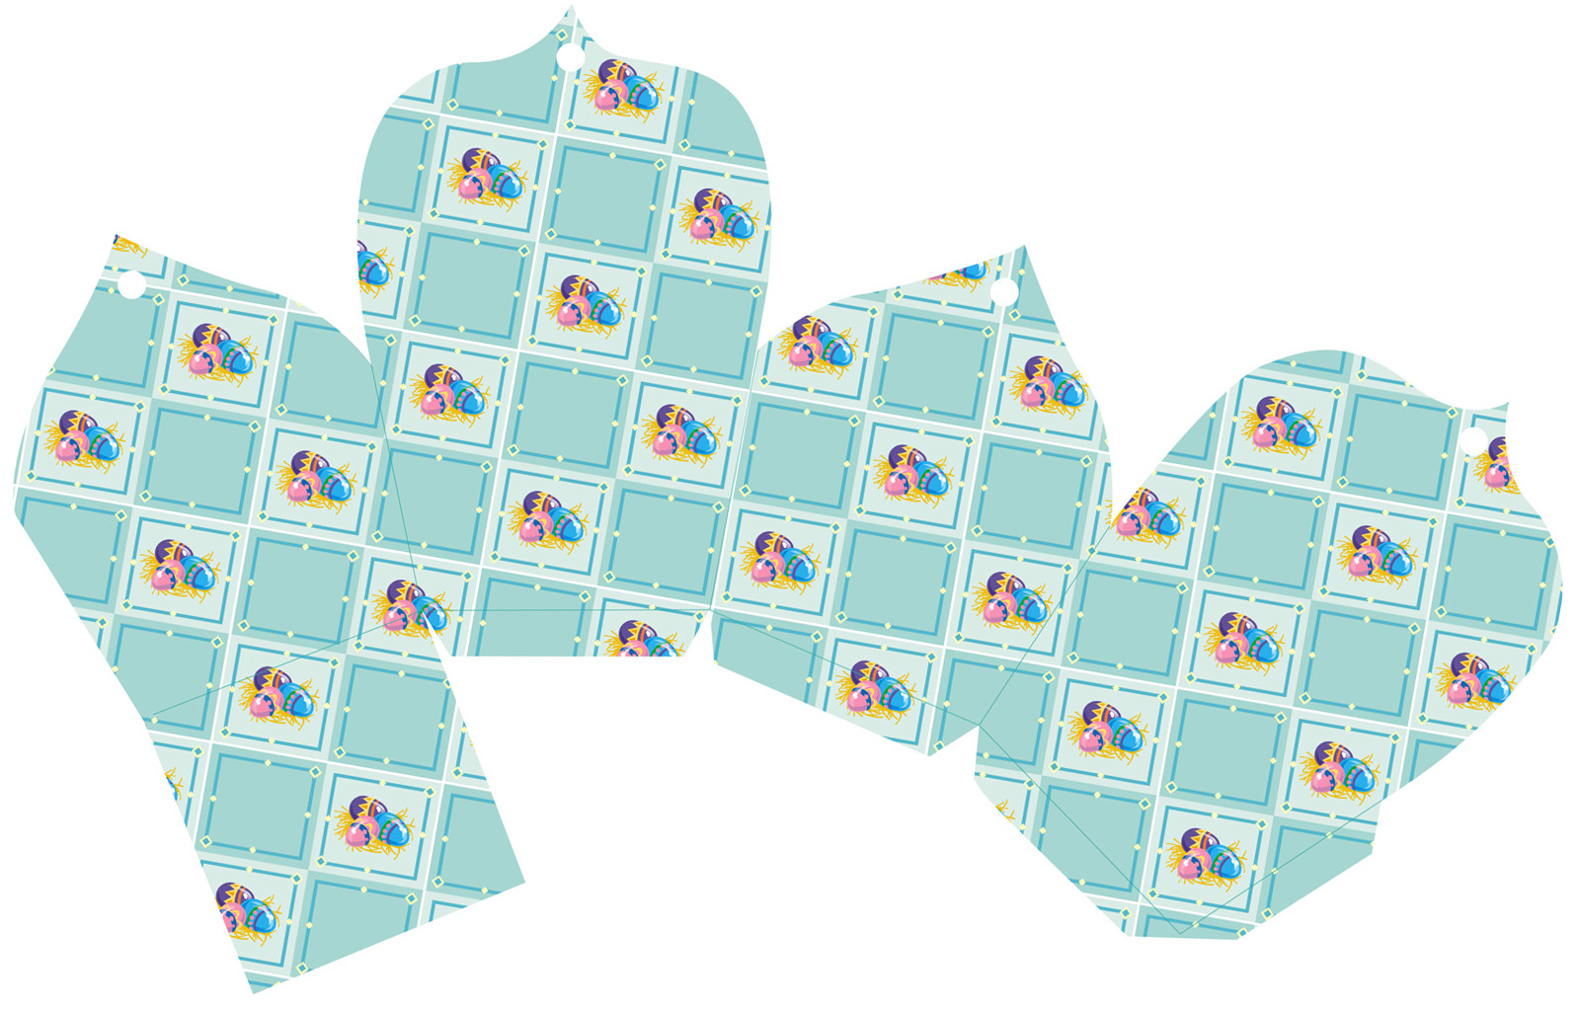
Happy Easter
to my little bunny,
(Name Here)

